**NOTE**: You need a public StartUp class with the namespace Cars.

Build a **hierarchy** of **interfaces** and **classes**:

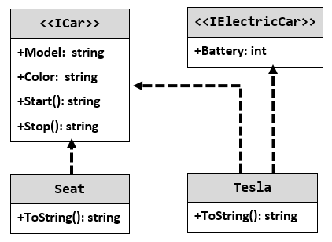

Your hierarchy must be used with this code:

|  |
| --- |
| StartUp.cs |
| ICar seat = new Seat("Leon", "Grey");  ICar tesla = new Tesla("Model 3", "Red", 2);  Console.WriteLine(seat.ToString());  Console.WriteLine(tesla.ToString()); |